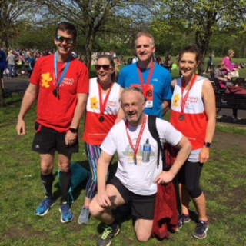
Marathon Success for Old School Surgery!

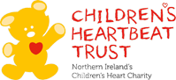

Congratulations to all our amazing doctors who completed the Belfast Marathon on 1 May 2017.

Dr's Kernohan, White, Bell & Alexander participated in the relay event & Dr Bradley completed the whole 26 miles! This year the doctors raised donations in aid to the Children's Heartbeat Trust. This is a local charity who works closely with the Clark Clinic at the RBHSC to ensure children with heart disease and their families receive the best care, treatment and support possible. It is a charity solely funded by the generosity of the public.

Thank you to everyone who has donated. The amount raised so far is: £1090.00.

There is still time to donate to this amazing charity via our 'Just giving' page at: https://www.justgiving.com/fundraising/oldschoolsurgery or simply call into reception.

If you would like further information regarding the Children's Heartbeat Trust please visit www.childrensheartbeattrust.org.

